Joel Atkinson
December 14, 2025
CSD420 Advanced Java Programming
Assignment 10.2

Code:
//Joel Atkinson December 14, 2025 CSD420 Advanced Java Programming Assignment 10.2
/* The purpose of this assignment is to build a GUI that connects to a SQL database called 'fans' and allows you to update
the database through this GUI by changing ID numbers, first names, last names, and favorite teams.
*/
import javax.swing.*;
import java.awt.*;
import java.awt.event.*;
import java.sql.*;
public class FanManager extends JFrame {
private static final String DB_URL = "jdbc:mysql://localhost:3306/databasedb";
private static final String DB_USER = "student1";
private static final String DB_PASSWORD = "pass";
private JTextField txtId;
private JTextField txtFirstName;
private JTextField txtLastName;
private JTextField txtFavoriteTeam;
private JButton btnDisplay;
private JButton btnUpdate;
private Connection connection;
public FanManager() {
setTitle("Fan Information Manager");
setSize(500, 400);
setDefaultCloseOperation(JFrame.EXIT_ON_CLOSE);
setLocationRelativeTo(null);
setLayout(new GridBagLayout());
GridBagConstraints gbc = new GridBagConstraints();
gbc.insets = new Insets(10, 10, 10, 10);
gbc.anchor = GridBagConstraints.WEST;
gbc.gridx = 0; gbc.gridy = 0;
add(new JLabel("ID:"), gbc);
gbc.gridx = 1;
txtId = new JTextField(20);
add(txtId, gbc);
gbc.gridx = 0; gbc.gridy = 1;
add(new JLabel("First Name:"), gbc);
gbc.gridx = 1;
txtFirstName = new JTextField(20);
add(txtFirstName, gbc);
gbc.gridx = 0; gbc.gridy = 2;
add(new JLabel("Last Name:"), gbc);
gbc.gridx = 1;
txtLastName = new JTextField(20);
add(txtLastName, gbc);
gbc.gridx = 0; gbc.gridy = 3;
add(new JLabel("Favorite Team:"), gbc);
gbc.gridx = 1;
txtFavoriteTeam = new JTextField(20);
add(txtFavoriteTeam, gbc);
JPanel buttonPanel = new JPanel();
btnDisplay = new JButton("Display Record");
btnUpdate = new JButton("Update Record");
buttonPanel.add(btnDisplay);
buttonPanel.add(btnUpdate);
gbc.gridx = 0; gbc.gridy = 4;
gbc.gridwidth = 2;
gbc.anchor = GridBagConstraints.CENTER;
add(buttonPanel, gbc);
connectToDatabase();
btnDisplay.addActionListener(e -> displayRecord());
btnUpdate.addActionListener(e -> updateRecord());
}
private void connectToDatabase() {
try {
connection = DriverManager.getConnection(DB_URL, DB_USER, DB_PASSWORD);
} catch (SQLException e) {
JOptionPane.showMessageDialog(this,
"Failed to connect to database:\n" + e.getMessage(),
"Database Error", JOptionPane.ERROR_MESSAGE);
System.exit(1);
}
}
private void displayRecord() {
String idText = txtId.getText().trim();
if (idText.isEmpty()) {
JOptionPane.showMessageDialog(this, "Please Enter an ID Number");
return;
}
int id;
try {
id = Integer.parseInt(idText);
} catch (NumberFormatException e) {
JOptionPane.showMessageDialog(this, "ID Must Be a Number");
return;
}
String query = "SELECT firstname, lastname, favoriteteam FROM fans WHERE ID = ?";
try (PreparedStatement pstmt = connection.prepareStatement(query)) {
pstmt.setInt(1, id);
try (ResultSet rs = pstmt.executeQuery()) {
if (rs.next()) {
txtFirstName.setText(rs.getString("firstname"));
txtLastName.setText(rs.getString("lastname"));
txtFavoriteTeam.setText(rs.getString("favoriteteam"));
} else {
JOptionPane.showMessageDialog(this, "No Fan Found with ID " + id);
txtFirstName.setText("");
txtLastName.setText("");
txtFavoriteTeam.setText("");
}
}
} catch (SQLException e) {
JOptionPane.showMessageDialog(this, "Error Retrieving Record:\n" + e.getMessage());
}
}
private void updateRecord() {
String idText = txtId.getText().trim();
if (idText.isEmpty()) {
JOptionPane.showMessageDialog(this, "Please Enter an ID Number");
return;
}
int id;
try {
id = Integer.parseInt(idText);
} catch (NumberFormatException e) {
JOptionPane.showMessageDialog(this, "ID must be a number.");
return;
}
String firstName = txtFirstName.getText().trim();
String lastName = txtLastName.getText().trim();
String favoriteTeam = txtFavoriteTeam.getText().trim();
String query = "UPDATE fans SET firstname = ?, lastname = ?, favoriteteam = ? WHERE ID = ?";
try (PreparedStatement pstmt = connection.prepareStatement(query)) {
pstmt.setString(1, firstName);
pstmt.setString(2, lastName);
pstmt.setString(3, favoriteTeam);
pstmt.setInt(4, id);
int rowsAffected = pstmt.executeUpdate();
if (rowsAffected > 0) {
JOptionPane.showMessageDialog(this, "Record Updated Successfully");
} else {
JOptionPane.showMessageDialog(this, "No record found with ID " + id + " to update");
}
} catch (SQLException e) {
JOptionPane.showMessageDialog(this, "Error Updating Record:\n" + e.getMessage());
}
}
@Override
protected void finalize() throws Throwable {
if (connection != null && !connection.isClosed()) {
connection.close();
}
super.finalize();
}
public static void main(String[] args) {
SwingUtilities.invokeLater(() -> {
new FanManager().setVisible(true);
});
}
}

Screenshot of Blank GUI Output:
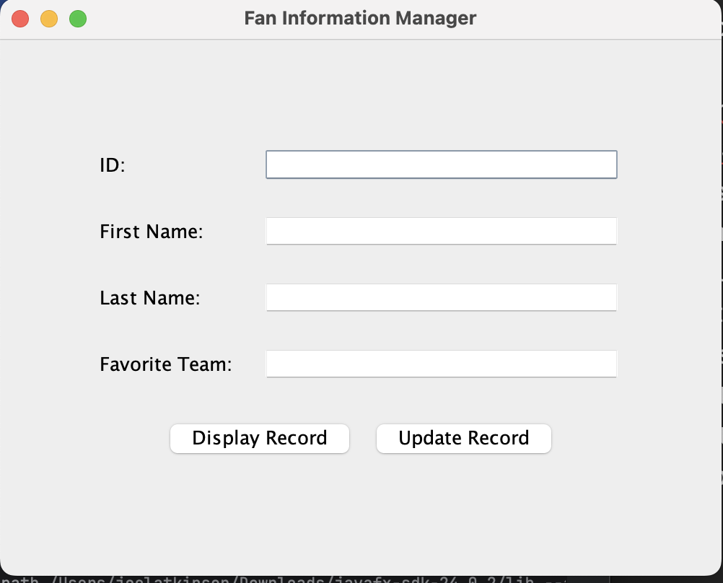
Screenshot of GUI with Record Displayed:
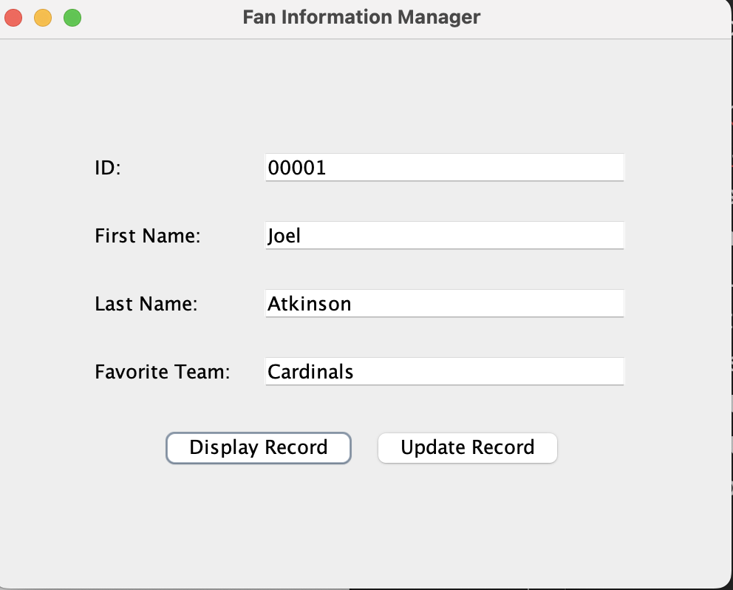
Screenshot of my SQL setup. I accidentally added the data wrong originally by entering the first names in the last name column and the last names in the first name column. This actually worked out nicely because it allowed me to use my GUI to update the records which then was reflected when I SELECT * FROM fans in SQL.
